36088 Federal Register / Vol. 70, No. 119 / Wednesday, June 22, 2005 / Proposed Rules

with the intent that the national government should be deferential to the States when taking action that affects the policymaking discretion of the States.

Executive Order 12988
The Compact Council is not an executive agency or independent establishment as defined in 5 U.S.C.
105; accordingly, Executive Order 12988
is not applicable.

Unfunded Mandates Reform Act
Approximately 75 percent of the Compact Council members are representatives of state and local governments; accordingly, rules prescribed by the Compact Council are not Federal mandates. Accordingly, no actions are deemed necessary under the provisions of the Unfunded Mandates Reform Act of 1995.

Small Business Regulatory Enforcement
Fairness Act of 1996
The Small Business Regulatory
Enforcement Fairness Act (5 U.S.C. 801–
804) is not applicable to the Council’s rule because the Compact Council is not a ‘‘Federal agency’’ as defined by 5
U.S.C. 804(1). Likewise, the reporting requirement of the Congressional Review Act (Subtitle E of the Small Business Regulatory Enforcement

Requirements as established by the Compact Council (Council). The Council is established pursuant to the National Crime Prevention and Privacy Compact Act (Compact), title 42, U.S.C.,
14616.

§ 905.3 Participation in the NFF Program. Each NFF Program participant shall meet the standards set forth in the NFF
Qualification Requirements as established by the Council and endorsed by the FBI’s Criminal Justice
Information Services Advisory Policy Board; however, such standards shall not interfere or conflict with the FBI’s administration of the III, including the NFF, for criminal justice purposes. Each participant’s performance will be audited and measured by criteria designed to assess compliance with those requirements. Measurements by which to determine compliance to the NFF Qualification Requirements are outlined in the FBI and State Sampling Standards. (For a copy of the standards, contact the FBI Compact Officer, 1000
Custer Hollow Road, Module C–3, Clarksburg, WV 26306–0001.) Dated: May 12, 2005.
Donna M. Uzzell,
Compact Council Chairman.
[FR Doc. 05–12330 Filed 6–21–05; 8:45 am]
BILLING CODE 4410–02–P

Federal eRulemaking Portal: http:// www.regulations.gov. Follow the instructions for submitting comments.
Agency Web Site: http:// www.gsa.gov/fmr. Click on the FMR case number to submit comments.
E-mail: fmrcase.2005–102–
4@gsa.gov. Include FMR case 2005–
102–4 in the subject line of the message.
Fax: 202–501–4067.
Mail: General Services
Administration, Regulatory Secretariat
(VIR), 1800 F Street, NW., Room 4035, ATTN: Laurieann Duarte, Washington, DC 20405.
Instructions: Please submit comments only and cite FMR case 2005–102–4 in all correspondence related to this case. All comments received will be posted without change to http://www.gsa.gov/ fmr, including any personal information provided.
FOR FURTHER INFORMATION CONTACT: The Regulatory Secretariat, Room 4035, GS Building, Washington, DC, 20405, at
(202) 208–7312 for information pertaining to status or publication schedules. For clarification of content, contact Ms. Elizabeth Allison, Office of Governmentwide Policy, Transportation Management Policy Division, at (202)
219–1792 or e-mail at elizabeth.allison@gsa.gov. Please cite FMR case 2005–102–4.

Fairness Act) does not apply. See 5
U.S.C. 804.

List of Subjects in 28 CFR Part 905
SUPPLEMENTARY INFORMATION:

A. Background
GENERAL SERVICES

Crime, Privacy, Information, Safety. Accordingly, title 28 of the Code of Federal Regulations is proposed to be amended by adding Part 905 to read as
follows:

PART 905—NATIONAL FINGERPRINT FILE (NFF) PROGRAM QUALIFICATION REQUIREMENTS

Sec.
905.1 Definition.
905.2 Purpose and authority.
905.3 Participation in the NFF Program.
Authority: 42 U.S.C. 14616.

§ 905.1 Definition.
‘‘National Fingerprint File’’ means a database of fingerprints, or other uniquely personal identifying information, relating to an arrested or charged individual maintained by the FBI to provide positive identification of record subjects indexed in the III System.

§ 905.2 Purpose and authority.
The purpose of this part 905 is to require each National Fingerprint File
(NFF) participant to meet the standards set forth in the NFF Qualification
ADMINISTRATION

41 CFR Parts 102–117 and 102–118
[FMR Case 2005–102–4] RIN 3090–AI11

Federal Management Regulation; Transportation Management and Transportation Payment and Audit— Data Collection Standards and Reporting Requirements

AGENCY: Office of Governmentwide
Policy, General Services Administration
(GSA).
ACTION: Proposed rule.

SUMMARY: The General Services Administration is amending the Federal Management Regulation (FMR) by adding specific data collection standards and reporting requirements. The FMR and any corresponding documents may be accessed at GSA’s Web site at http://www.gsa.gov/fmr. DATES: Comments are due on or before August 22, 2005.
ADDRESSES: Submit comments identified by FMR case 2005–102–4 by any of the following methods:
Part 102–117 of the Federal Management Regulation (FMR) (41 CFR part 102–117, Transportation Management), currently states that there is no requirement for reporting on agency transportation activities. Over the past several years, the General Services Administration (GSA) has worked with the Governmentwide Transportation Policy Council (GTPC) interagency working group to develop standards for transportation data collection.
GSA and its partner agencies determined that better information about agency transportation services would provide critical input for more informed decision making. Transportation is often viewed as support for other essential activities, and data is often not accorded high visibility or priority in determining budget allocations. The data necessary to facilitate sound transportation policy making are seriously inadequate, and the organization of data collection activities in the agencies is not conducive to providing them. The decentralized programs of the agencies, although appropriate to the missions of the operating administrations, are not

VerDate jul<14>2003 16:16 Jun 21, 2005 Jkt 205001 PO 00000 Frm 00034 Fmt 4702 Sfmt 4702 E:\FR\FM\22JNP1.SGM 22JNP1

Federal Register / Vol. 70, No. 119 / Wednesday, June 22, 2005 / Proposed Rules
36089

well structured to address the strategic, cross-cutting, system wide issues that face agencies today.
As leaders in Government, it is paramount that transportation managers make informed transportation decisions based on fact. Quality data is paramount in identifying alternative strategies and evaluating performance and results.
Data will further provide accurate, reliable budget figures to advance the effective use of data for informed decision making and accurate agency budget submissions.

B. Substantive Changes

This proposed rule adds the requirement and clarifies the collection of transportation data, analysis and reporting to improve information needs of decision makers in FMR Part 102–117 and links prepayment audit in FMR Part
102–118 to data collection in FMR Part
102–117. To ensure that the agency transportation managers have a more solid knowledge base to support investment and regulatory decisions, which involve billions of dollars, GSA proposes to institute an annual Governmentwide transportation data call.

C. Executive Order 12866

GSA has determined that this proposed rule is not a significant rule for the purposes of Executive Order
12866 of September 30, 1993.

D. Regulatory Flexibility Act

This proposed rule is not required to be published in the Federal Register for notice and comment; therefore the Regulatory Flexibility Act, 5 U.S.C. 601, et seq., does not apply because the rule only applies to internal agency management and will not have a significant effect on the public.

E. Paperwork Reduction Act

The Paperwork Reduction Act does not apply because the proposed rule does not impose recordkeeping or information collection requirements, or the collection of information from offerors, contractors, or members of the public which require the approval of the Office of Management and Budget
(OMB) under 44 U.S.C. 3501 et seq. F. Small Business Regulatory Enforcement Fairness Act

This proposed rule is exempt from
Congressional review prescribed under
5 U.S.C. 801 since it relates solely to agency management and personnel.

List of Subjects in 41 CFR Parts 102–117
and 102–118
Accounting, Claims, Government property management, Reporting and recordkeeping requirements, Surplus Government property, Transportation. Dated: May 18, 2005.
G. Martin Wagner,
Associate Administrator,Office of
Governmentwide Policy.
For the reasons set forth in the preamble, GSA proposes to amend 41
CFR parts 102–117 and 102–118 as follows:

PART 102–117—TRANSPORTATION MANAGEMENT

1. The authority citation for 41 CFR part 102–117 continues to read as follows:
Authority: 31 U.S.C. 3726; 40 U.S.C. 481,
et seq.
2. Amend § 102–117.25 by adding, in alphabetical order, the definitions
‘‘Barge’’, ‘‘Boxcar’’, ‘‘Break bulk’’, ‘‘Bulk cargo’’, ‘‘Container’’, ‘‘Dry bulk’’,
‘‘Flatcar’’, ‘‘Intermodal’’, ‘‘LASH
(Lighter Aboard Ship) barge’’, ‘‘Less- than-truck load (LTL)’’, ‘‘Liquid bulk’’,
‘‘Measured ton’’, ‘‘Specialized cargo’’,
‘‘Ton mile’’, and ‘‘Truck Load’’; and by revising the definition ‘‘Mode’’ to read as follows:

§ 102–117.25 What definitions apply to this part?
* * * * *
Barge means a flat-bottomed boat designed to carry cargo on inland waterways, usually without engines or crew accommodations. Small barges for carrying cargo between ship and shore are known as lighters.
* * * * *
Boxcar means an enclosed railcar, typically 40 to 50 feet long, used for packaged freight and some bulk commodities.
Break bulk means general freight or cargo that is transported in units and not containerized. Examples of break bulk are lumber and steel. Break bulk cargo is the separation of a consolidated bulk load into smaller individual shipments for delivery to the ultimate consignee. Freight may be moved intact
inside a trailer or it may be interchanged and re-handled to connecting carriers. Bulk cargo means freight or cargo transported in mass, not in packages or containers. Examples of bulk cargo are grain or fertilizer.
* * * * *
Container usually means a large box
(10 to 40 feet long) into which freight is loaded or for holding/bundling

commodities. Examples of containers are boxes, crates, cartons, cans or barrels.
* * * * *
Dry bulk means merchandise other than liquid carried in bulk, i.e., grain and fertilizer.
* * * * *
Flatcar means a railcar without sides used for hauling machines.
* * * * *
Intermodal denotes movements of cargo containers interchangeably between transport modes, i.e., motor, water, and air carriers.
LASH (Lighter Aboard Ship) barge means a covered barge that is loaded on board ocean going ships for movement to foreign destinations.
Less-than-truck load (LTL) means a shipment weighing less than the minimum weight needed to use the lower truck load rate.
* * * * *
Liquid bulk means merchandise other than dry bulk carried in bulk, i.e., oil and propane.
Measured ton equals 40 cubic feet, used in water transportation rate setting.
Mode refers to the different methods of shipment i.e., motor, water or air.
* * * * *
Specialized cargo means non containerized cargo such as automobiles or cattle.
* * * * *
Ton mile means the transportation of one ton of freight for a distance of one mile.
* * * * *
Truck Load means the quantity of freight required to fill a trailer; usually more than 10,000 pounds.
* * * * *

§§ 102–117.355 and 102–117.360
[Redesignated as §§ 102–117.400 and 102–
117.405]
3. Redesignate §§ 102–117.355 and
102–117.360 as §§ 102–117.400 and
102–117.405, respectively.
4. Revise Part 102–117, Subpart K, to read as follows:

PART 102–117—TRANSPORTATION MANAGEMENT

Subpart K—Reports

Sec.
102–117.345 Is there a requirement for me to report to GSA on my transportation activities?
102–117.350 What data do I have to report?
102–117.355 What data form do I have to use?
102–117.360 When do I have to report?
102–117.365 How can the data be collected?
102–117.370 Are there other reporting requirements?

VerDate jul<14>2003 16:16 Jun 21, 2005 Jkt 205001 PO 00000 Frm 00035 Fmt 4702 Sfmt 4702 E:\FR\FM\22JNP1.SGM 22JNP1

36090 Federal Register / Vol. 70, No. 119 / Wednesday, June 22, 2005 / Proposed Rules

102–117.375 What tasks does proper reporting of data involve?
102–117.380 Why is it important to report data and what is the value of the data collected to my agency?
102–117.385 What are the consequences of not reporting?
102–117.390 Where do I find further information or assistance?
102–117.395 How will GSA use reports I
submit?

Subpart K—Reports

§ 102–117.345 Is there a requirement for me to report to GSA on my transportation activities?

(a) Yes, your agency must report your transportation activities to GSA on an annual basis.
(b) Monthly reports with year to date information will be gathered and maintained by the transportation manager with an annual report forwarded to GSA.

§ 102–117.350 What data do I have to report?
There are five groups of data which you may be obligated to report. Which categories you have to report on is largely dependent on the specific transportation activities of your agency. Your agency must collect information on the following categories:
(a) Mode.
(b) Measure.
(1) Weight-tons (short tons 2000 lbs), pounds;
(2) Volume-cubage;
(3) Cost dollars paid per shipment and/or weight measure, volume, value; and
(4) Number of transactions and/or orders.
(c) Geography.
(1) Domestic by key regions.
(2) International.
(d) Key Corridors (Key city or origin and destination pairs).

(1) Federal Budget Object Classification 22, less than $1 million top 10 pairs.
(2) Federal Budget Object Classification 22, $1 million to $10 million top 15 pairs.
(3) Federal Budget Object Classification 22, $10 million up top 20 pairs.
(e) Commodities.
(1) General freight.
(2) Household goods shipments.
(3) Hazardous cargo shipments.

§ 102–117.355 What data form do I have to use?
The following format is suggested but not mandatory for reporting your data. All reports will be electronically stored, processed and sent electronically. Agencies may use any available electronic system, but systems must be capable of interfacing with other systems and GSA.
BILLING CODE 6820–14–P

VerDate jul<14>2003 16:16 Jun 21, 2005 Jkt 205001 PO 00000 Frm 00036 Fmt 4702 Sfmt 4702 E:\FR\FM\22JNP1.SGM 22JNP1

Federal Register / Vol. 70, No. 119 / Wednesday, June 22, 2005 / Proposed Rules
36091

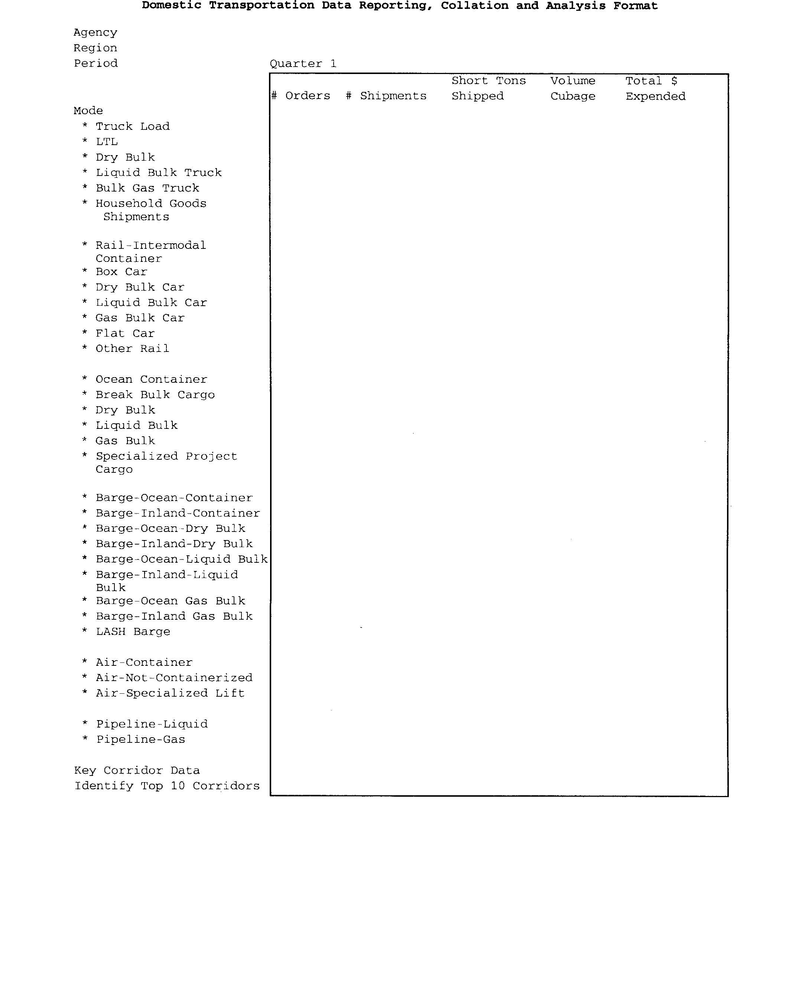

VerDate jul<14>2003 16:16 Jun 21, 2005 Jkt 205001 PO 00000 Frm 00037 Fmt 4702 Sfmt 4725 E:\FR\FM\22JNP1.SGM 22JNP1

36092 Federal Register / Vol. 70, No. 119 / Wednesday, June 22, 2005 / Proposed Rules

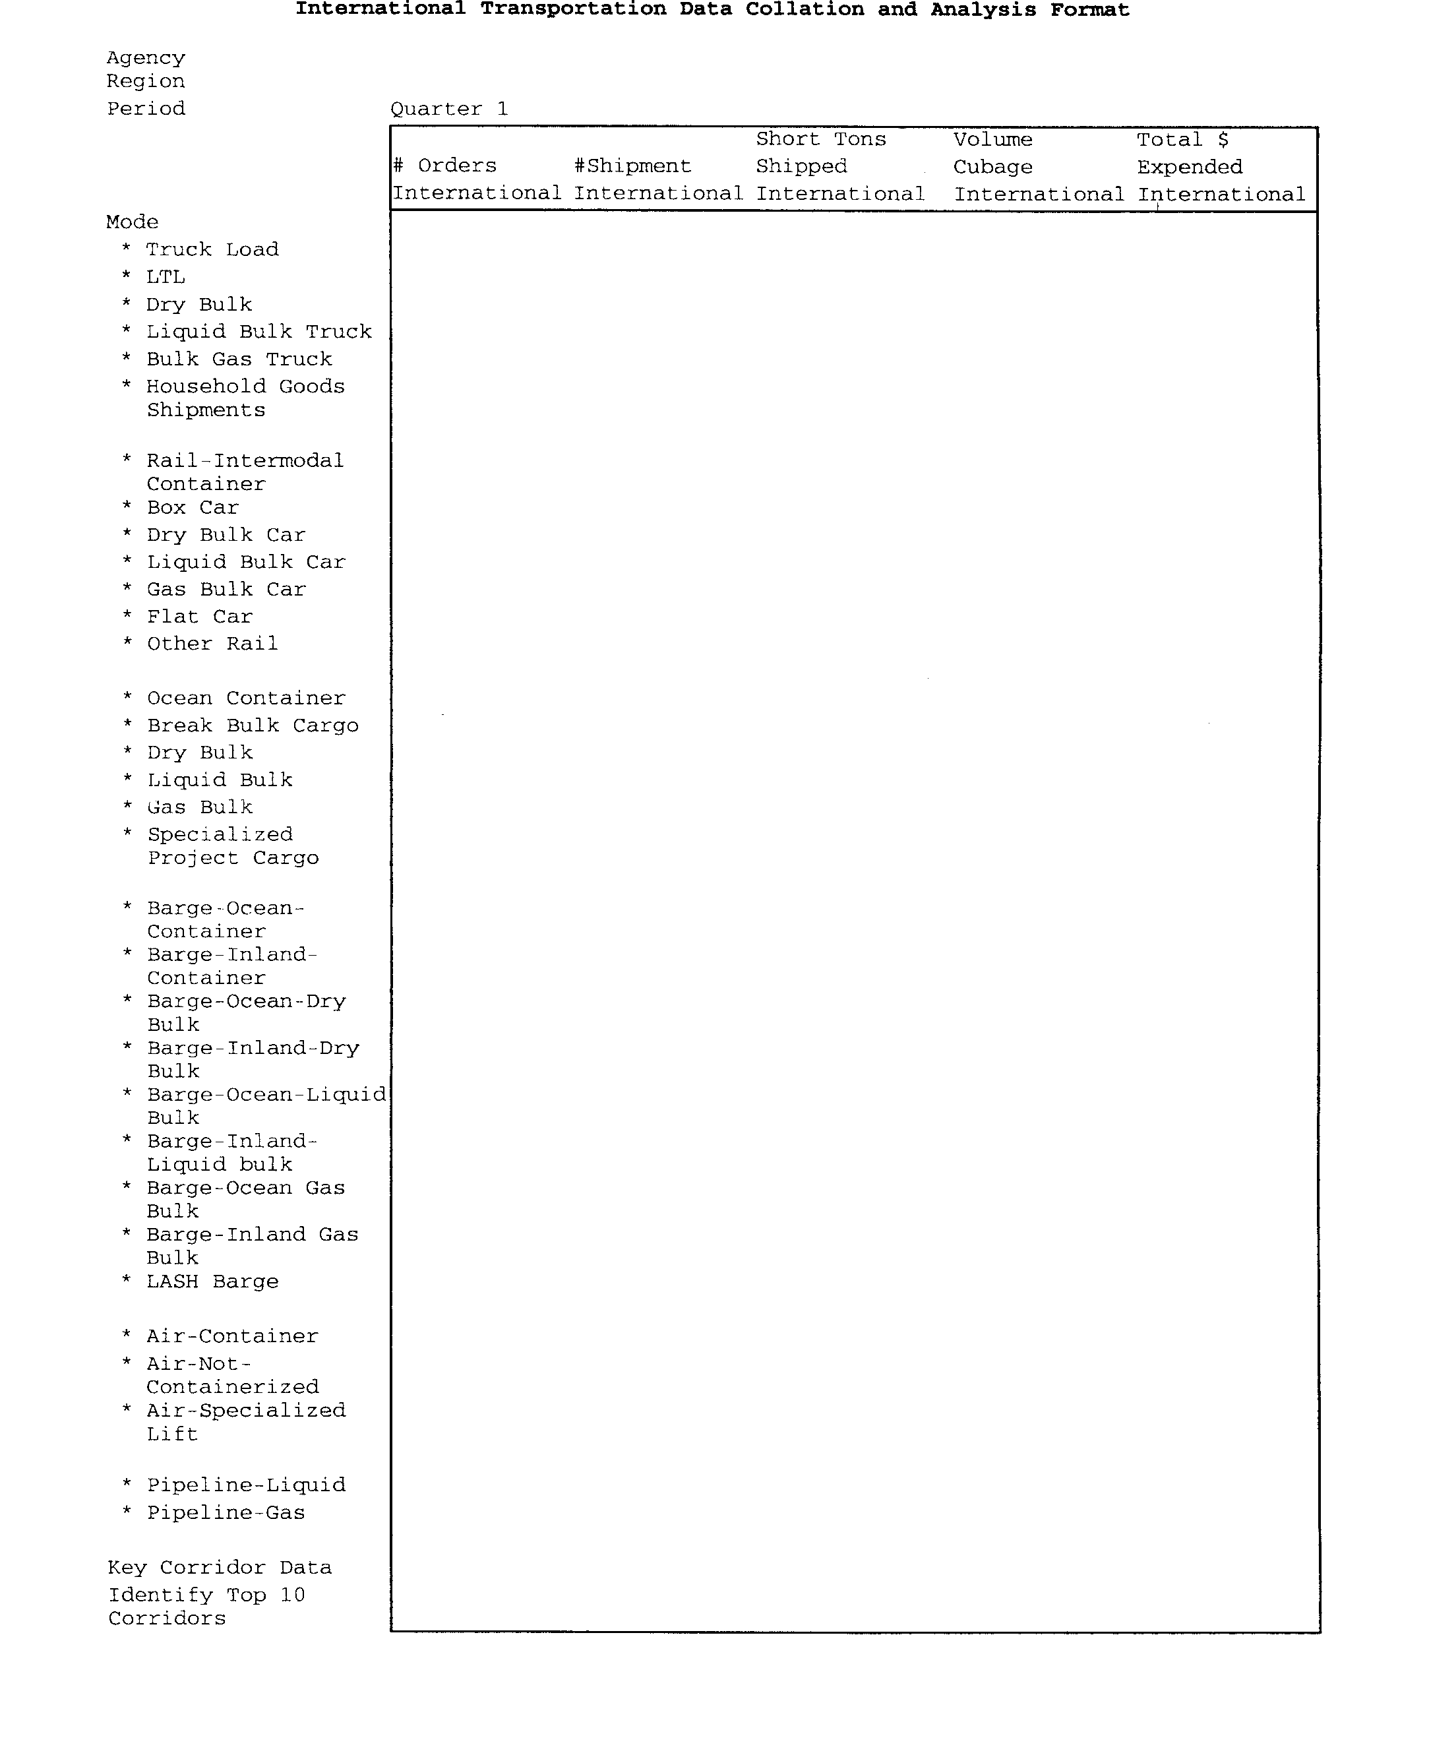

BILLING CODE 6820–14–C

VerDate jul<14>2003 16:16 Jun 21, 2005 Jkt 205001 PO 00000 Frm 00038 Fmt 4702 Sfmt 4702 E:\FR\FM\22JNP1.SGM 22JNP1

Federal Register / Vol. 70, No. 119 / Wednesday, June 22, 2005 / Proposed Rules
36093

§ 102–117.360 When do I have to report? Annual data reports to GSA are due by February 1 of each year and must
contain data related to the previous fiscal year. The first annual report will be due February 1, 2007. Reports will be sent to GSA, Office of Governmentwide Policy, Office of Travel, Transportation and Asset Management, http:// www.gsa.gov/transportationpolicy.

§ 102–117.365 How can the data be collected?
(a) A variety of transportation data is currently available, from microscopic, local data to macroscopic summary data and from hard-copy to stored electronic data.
(b) Agencies that utilize the Transportation Management Services Solution (TMSS) may download the requested information through the report module.
(c) All other agencies must have electronic systems in place.

§ 102–117.370 Are there other reporting requirements?
No, there are no other reporting requirements.

§ 102–117.375 What tasks does proper reporting of data involve?
Proper reporting of data involves three main tasks:
(a) Identifying your agency’s reporting obligations.
(b) Collecting the necessary data.
(c) Checking the data for accuracy and consistency.

§ 102–117.380 Why is it important to report data and what is the value of the data collected to my agency?
It is important to report data to identify and publicize sources of data on commodity movement, international trade, and freight transportation within the Federal Government. Information about agency transportation services will provide critical input for more informed decision making. This information will assist analysts and decision makers on the cost-effective ways to fulfill essential transportation needs; consider consolidated use of transportation services; more efficient use of agency transportation resources and more effective use of new or existing procurements. Quality data is paramount in identifying alternative strategies and evaluating performance and results. Data will further provide accurate, reliable budget figures to advance the effective use of data for accurate agency submissions.

§ 102–117.385 What are the consequences of not reporting?
Agencies not submitting data or submitting inconsistent data will be

requested by the General Services Administration (GSA) to comply with the data reporting requirements. GSA will report compliance to the Office of Management and Budget (OMB).

§ 102–117.390 Where do I find further information or assistance?
If you need further information or assistance, contact: General Services Administration, Office of Travel, Transportation and Asset Management
(MT), 1800 F Street, NW., Washington, DC 20405, or e-mail at http:// www.policyworks.gov/transportation.

§ 102–117.395 How will GSA use reports I
submit?
(a) Reporting on transportation and transportation related services will provide GSA with—
(1) The ability to assess the magnitude and key characteristics of transportation within the Government (e.g., how much agencies spend; what type of
commodity is shipped; etc.);
(2) Data to analyze and recommend changes to policies, standards, practices, and procedures to improve Government transportation; and
(3) A better understanding of how your activity relates to other agencies and your influence on the Government wide picture of transportation services.
(4) This data and analysis will further enable agencies to more accurately report budgets and expenses in the Federal Budget under Object Classification 22, Transportation of Things.
(b) In addition, this information will assist you in showing your management the magnitude of your agency’s transportation program and the effectiveness of your efforts to control cost and improve service.

PART 102–118—TRANSPORTATION PAYMENT AND AUDIT

5. The authority citation for 41 CFR part 102–118 continues to read as follows:
Authority: 31 U.S.C. 3726; and 40 U.S.C.
481, et seq.
6. Revise § 102–118.280 to read as follows:

§ 102–118.280 What advantages does the prepayment audit offer my agency?
(a) Prepayment auditing will allow your agency to detect and eliminate billing errors before payment and will eliminate the time and cost of recovering agency overpayments.
(b) Prepayment auditing will give you data on what is spent on transportation and provides accurate, reliable budget figures for informed decision making

and accurate agency budget submissions.
(c) Quality data is paramount in identifying alternative strategies and evaluating performance and results.
7. Add §§ 102–118.281 and 102–
118.282 to read as follows:

§ 102–118.281 How can my agency use the data collected in the prepayment audit?
Your agency can use the data collected in the prepayment audit to—
(a) Analyze cost-effective ways to fulfill essential transportation needs;
(b) Consider consolidated use of transportation services;
(c) Use agency transportation resources more effectively; and
(d) Use new or existing procurements more effectively.

§ 102–118.282 Is my agency required to report to the General Services Administration (GSA) on my transportation activities?
(a) Yes, your agency must report your transportation activities to the General Services Administration (GSA) on an annual basis.
(b) Monthly reports with year to date information will be gathered and maintained by the transportation manager with an annual report forwarded to GSA. See §§ 102–117.345 through 102.117.395 of this chapter for more details on the reporting requirement.

[FR Doc. 05–12282 Filed 6–21–05; 8:45 am]
BILLING CODE 6820–14–P

DEPARTMENT OF TRANSPORTATION Pipeline and Hazardous Materials Safety Administration

49 CFR Part 192

[Docket No. PHMSA–05–21305; Notice 1]

Pipeline Safety: Use of Polyamide-11
Plastic Pipe in Gas Pipelines

AGENCY: Office of Pipeline Safety, Pipeline and Hazardous Materials Safety Administration, DOT.
ACTION: Request for comments.

SUMMARY: The Office of Pipeline Safety
(OPS) seeks public comments on two petitions for rulemaking filed by Arkema, Inc. The petitions request changes to the gas pipeline safety regulations to increase the design factor for new polyamide—11 (PA–11) pipe and to allow use of PA–11 pipe for systems operating at up to 200 pounds per square inch gauge pressure (psig). These requested changes will allow the use of PA–11 pipe in gas pipelines in place of metal pipe.

VerDate jul<14>2003 16:16 Jun 21, 2005 Jkt 205001 PO 00000 Frm 00039 Fmt 4702 Sfmt 4702 E:\FR\FM\22JNP1.SGM 22JNP1

