How to Import a ICS file by adding an URL in Google Calendar

Google Calendar allows you insert an ICS file by adding an URL (we are pointing to the Web URL that the ICS file has been posted to).
- Log into your Google calendar.
Find “Other Calendars” and click on the pull down arrow on the right.
- On the left side of the page, find
“Other Calendars” and click on
the pull down arrow on the right.
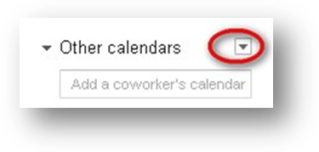

Click on “Add by URL.”
Click on “Add by URL.”
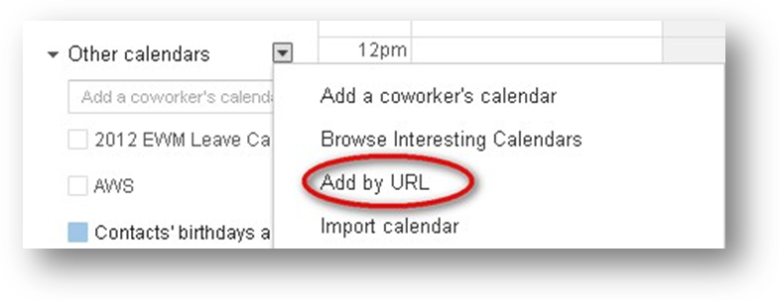

Insert this URL : https://www.google.com/calendar/ical/8uf250scchgqtjulqegqvhg0ik%40group.calendar.google.com/public/basic.ics
Insert URL here.
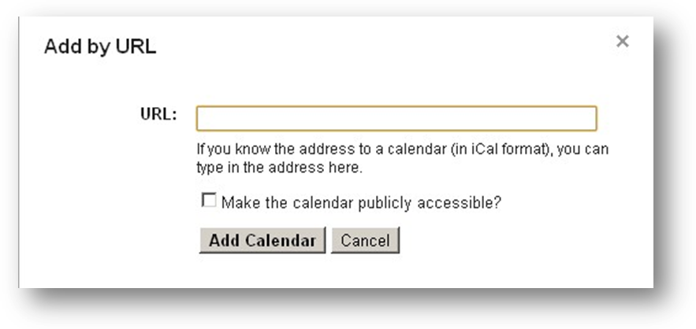

After you add the URL , click “Add Calendar.”
After you add the URL, click on “Add Calendar.”
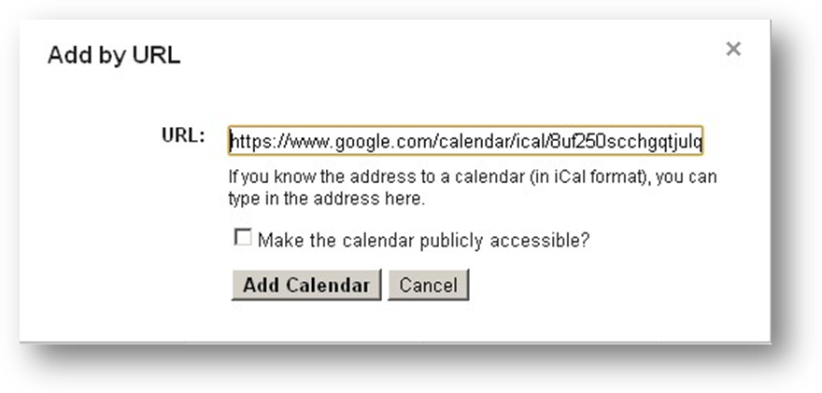

The GSA Payroll calendar will now appear under your “Other Calendars” on the left. You can customize or remove an online iCal calendar just like you would any other calendar under settings.
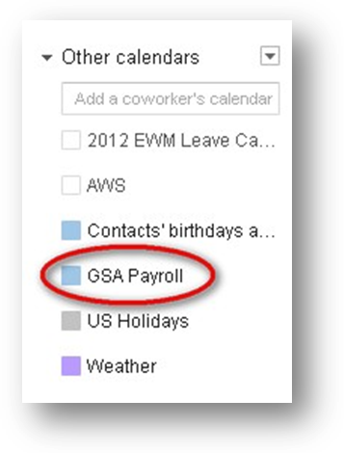
You will now see the payroll information on your calendar. You can toggle on the payroll calendar to turn it on and off.
