GENERAL SERVICES ADMINISTRATION February 4, 2005
Washington, DC 20405

FEDERAL MANAGEMENT REGULATION FEDERAL PROPERTY MANAGEMENT REGULATION
Amendment 2005-02

TO: Heads of Federal agencies

SUBJECT: FMR Case 2004-102-6; FPMR Case 2004-101-2, Interagency
Reports Management Program

1. Purpose. This document includes pages that reflect amendments to Part 101-11 of the Federal Property Management Regulation (FPMR) and Part 102-195 of the Federal Management Regulation (FMR).

2. Background. This final rule deletes from the Federal Management Regulation (FMR) the specific requirements of the Interagency Reports Management Program. GSA has determined that these requirements no longer serve a useful purpose, in view of the evolution of Federal records management practices affecting records creation and Federal policies that encourage agencies to share information electronically, when authorized by law and regulation, particularly as an alternative to collecting additional information from the public.

3. Effective date. This rule was published in the Federal
Register and became effective on January 19, 2005.

4. Explanation of changes. This final rule amends the FPMR and FMR by deleting the specific requirements of the Interagency Reports Management Program at FPMR 101-11 and FMR part 102-195.
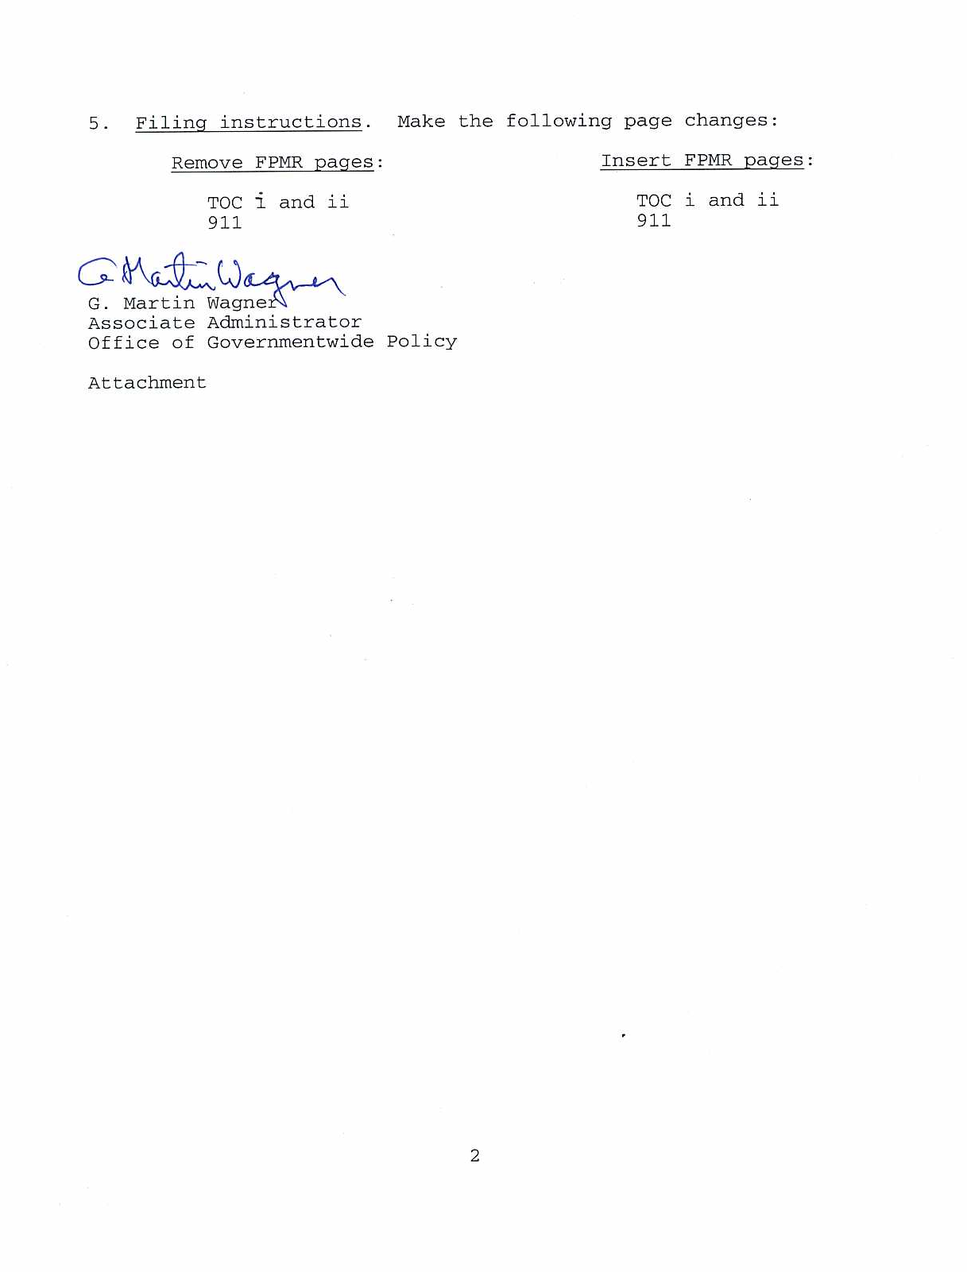
CONTENTS OF SUBCHAPTER B—MANAGEMENT AND USE OF INFORMATION AND RECORDS

PART 101-11—FEDERAL RECORDS AND STANDARD AND OPTIONAL FORMS

Sec.
101-11.000.............. Cross-reference to the Federal Management Regulation parts 102-193 and 102-194.

FEDERAL PROPERTY MANAGEMENT REGULATIONS
(FPMR - FMR AMENDMENT 2005-02, JANUARY 19, 2005)

i
CONTENTS OF SUBCHAPTER B—MANAGEMENT AND USE OF INFORMATION AND RECORDS

FEDERAL PROPERTY MANAGEMENT REGULATIONS
(FPMR - FMR AMENDMENT 2005-02, JANUARY 19, 2005)

ii
SUBCHAPTER B—MANAGEMENT AND USE OF INFORMATION AND RECORDS

PART 101-11—FEDERAL RECORDS AND STANDARD AND OPTIONAL FORMS

101-11.0

§101-11.000 Cross-reference to the Federal Management

Regulation (FMR) (102-193 and 102-194).

For information on records and standard and optional

forms, see FMR parts 102-193 and 102-194.

(Next page is 1701)

FEDERAL PROPERTY MANAGEMENT REGULATIONS
(FPMR - FMR AMENDMENT 2005-02, JANUARY 19, 2005)

911

(Reverse blank)

GENERAL SERVICES ADMINISTRATION February 4, 2005
Washington, DC 20405

FEDERAL MANAGEMENT REGULATION FEDERAL PROPERTY MANAGEMENT REGULATION
Amendment 2005-02

TO: Heads of Federal agencies

SUBJECT: FMR Case 2004-102-6; FPMR Case 2004-101-2; Interagency
Reports Management Program

1. Purpose. This document includes pages that reflect amendments to Part 101-11 of the Federal Property Management Regulation (FPMR) and Part 102-195 of the Federal Management Regulation (FMR).

2. Background. This final rule deletes from the Federal Management Regulation (FMR) the specific requirements of the Interagency Reports Management Program. GSA has determined that these requirements no longer serve a useful purpose, in view of the evolution of Federal records management practices affecting records creation and Federal policies that encourage agencies to share information electronically, when authorized by law and regulation, particularly as an alternative to collecting additional information from the public.

3. Effective date. This rule was published in the Federal
Register and became effective on January 19, 2005.

4. Explanation of changes. This final rule amends the FPMR and FMR by deleting the specific requirements of the Interagency Reports Management Program at FPMR 101-11 and FMR part 102-195.
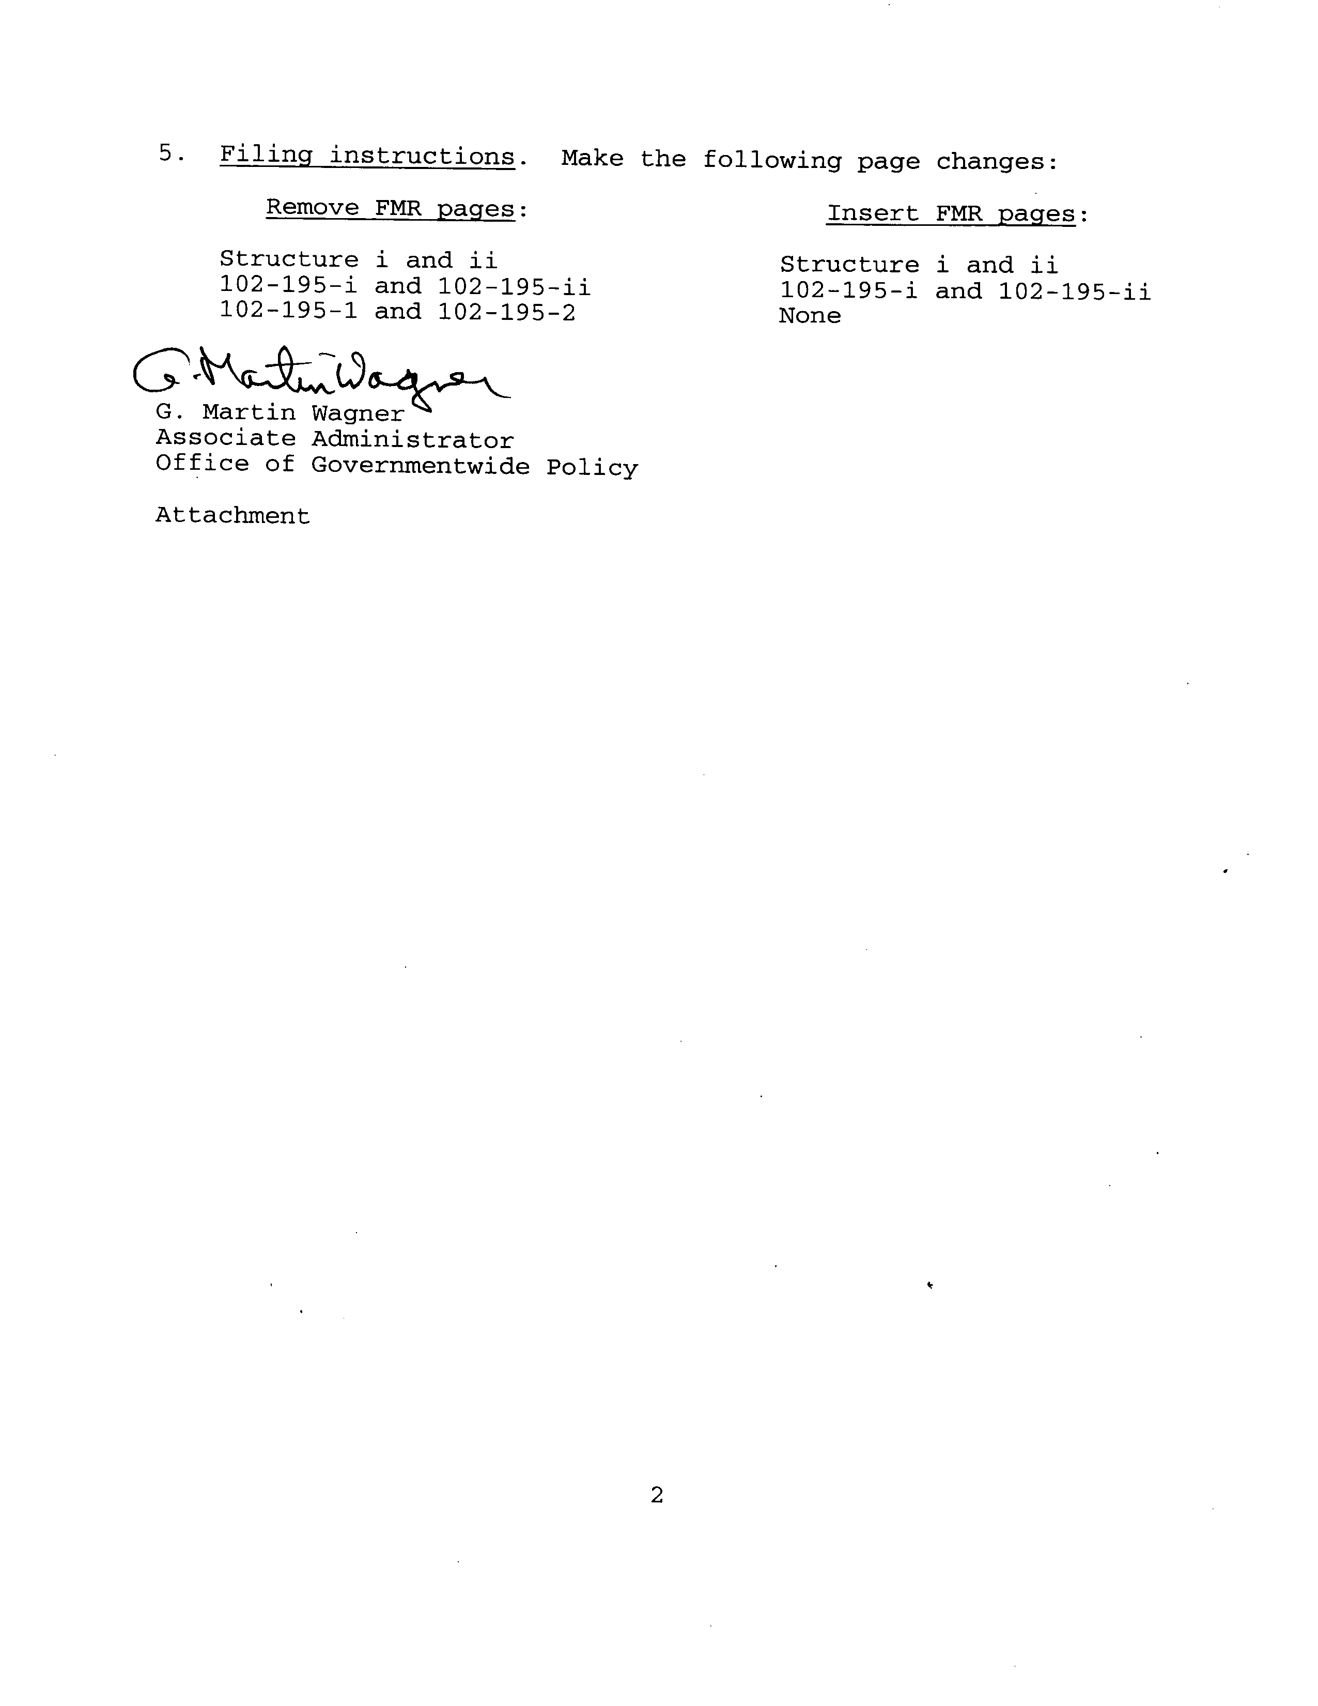
FEDERAL MANAGEMENT REGULATION

General Structure and Parts

102-1 General [Reserved]

SUBCHAPTER A—GENERAL

102-2 Federal Management Regulation System
102-3 Federal Advisory Committee Management
102-4 Nondiscrimination in Federal Financial Assistance Programs [Reserved]
102-5 Home-to-Work Transportation

SUBCHAPTER B—PERSONAL PROPERTY

102-31 General [Reserved]
102-32 Management of Personal Property [Reserved]
102-33 Management of Government Aircraft
102-34 Motor Vehicle Management
102-35 Disposition of Personal Property [Reserved]
102-36 Disposition of Excess Personal Property
102-37 Donation of Surplus Personal Property
102-38 Sale of Personal Property
102-39 Replacement of Personal Property Pursuant to the Exchange/Sale Authority
102-40 [Reserved]
102-41 [Reserved]
102-42 Utilization, Donation, and Disposal of Foreign Gifts and Decorations

102-71 General

SUBCHAPTER C—REAL PROPERTY

102-72 Delegation of Authority
102-73 Real Estate Acquisition
102-74 Facility Management
102-75 Real Property Disposal
102-76 Design and Construction
102-77 Art-in-Architecture
102-78 Historic Preservation
102-79 Assignment and Utilization of Space
102-80 Safety and Environmental Management
102-81 Security
102-82 Utility Services
102-83 Location of Space
102-84 Annual Real Property Inventories

i (FPMR-FMR Amendment 2005–02)

AMENDMENT 2005–02 JANUARY 19, 2005

STRUCTURE FEDERAL MANAGEMENT REGULATION

SUBCHAPTER D—TRANSPORTATION

102-116 General [Reserved]
102-117 Transportation Management
102-118 Transportation Payment and Audit

SUBCHAPTER E—TRAVEL MANAGEMENT

102-141 General [Reserved]

SUBCHAPTER F—TELECOMMUNICATIONS

102-171 General [Reserved]
102-172 Telecommunications Management Policy [Reserved]
102-173 Internet GOV Domain

SUBCHAPTER G—ADMINISTRATIVE PROGRAMS

102-191 General [Reserved]
102-192 Mail Management
102-193 Creation, Maintenance, and Use of Records
102-194 Standard and Optional Forms Management Program
102-195 [Reserved]
102-196 Federal Facility Ridesharing [Reserved]

ii
AMENDMENT 2005–02 JANUARY 19, 2005

PART 102-195—[RESERVED]

102-195-i
FEDERAL MANAGEMENT REGULATION

THIS PAGE INTENTIONALLY LEFT BLANK.

102-195-ii

